**CONTENT**

|  |  |  |
| --- | --- | --- |
| **S.No.** | **CONTENT** | **PAGE No.** |
| 1. | Abstract | 2 |
| 2. | Project Overview | 3 |
| 3. | System Design | 4 |
| 4. | Input Design | 8 |
| 5. | Output Design | 8 |
| 6. | Menu Level Description | 9 |
| 7. | Process Specification | 10 |
| 8. | Screen Layouts | 11 |
| 9. | Conclusion | 13 |
| 10. | Bibliography | 14 |

**ABSTRACT**

# The Online Vehicle Management System is a web-based application designed to simplify and automate the vehicle rental process for both customers and administrators. It eliminates the need for paper-based processes and walk-in bookings, providing a seamless online experience for users. Customers can browse a range of vehicles, select their preferred rental options, and submit their booking requests online. The platform supports various vehicle types, including scooters, bikes, and cars, and allows customers to view vehicle details, check availability, and make payments securely through the system.

# Administrators can efficiently manage the vehicle inventory, monitor vehicle statuses, and process rental requests through an integrated dashboard. The system allows administrators to add, edit, or remove vehicles from the listings, ensuring accurate and up-to-date information is available to customers. Additionally, the system tracks all rental transactions, providing reports on bookings, vehicle availability, and revenue generation.

# Developed using HTML, CSS, and JavaScript, the Online Vehicle Management System ensures a responsive and intuitive user interface across multiple devices. The system is designed to scale, supporting the future integration of features such as mobile apps, real-time notifications, GPS tracking for vehicles, and enhanced payment systems. With a focus on operational efficiency and customer satisfaction, the system enhances the vehicle rental experience by ensuring quick and easy access to vehicle services.

# This digital transformation in vehicle rental services addresses the growing need for automation in the industry, offering both customers and administrators a streamlined, transparent, and efficient way to manage vehicle bookings and rentals.

# INTRODUCTION

### PROJECT OVERVIEW

## The Online Vehicle Management System is a comprehensive, user-friendly platform designed to streamline the vehicle rental process for customers and administrators alike. This system aims to replace the traditional manual methods of renting vehicles, such as walk-in bookings and paper-based forms, with a more efficient and digital process.

## It provides a centralized online platform where customers can easily browse, book, and manage their vehicle rentals. The system is designed to cater to various types of vehicles, including scooters, bikes, and cars, offering flexibility and a wide range of options to suit different needs.

## Customers can search for available vehicles based on their preferred rental duration, vehicle type, and location. Once the desired vehicle is selected, they can fill out a booking form with personal details such as name, email, phone number, and rental preferences. The system validates the data entered, processes the booking request, and allows customers to make payments online for their rentals.

## For administrators, the system provides a dashboard that allows them to manage vehicle listings, track rental statuses, and review bookings. They can update vehicle availability, ensure proper maintenance, and manage customer interactions seamlessly. The system also features real-time updates, providing accurate and transparent information on vehicle status, availability, and rental history. This not only enhances operational efficiency but also improves customer satisfaction through streamlined services.

## Built using modern web technologies such as HTML, CSS, and JavaScript, the system ensures cross-platform compatibility, making it accessible via desktop and mobile devices. The flexible and modular architecture of the system ensures scalability, enabling easy integration with additional features such as mobile app support, customer feedback mechanisms, and advanced reporting tools.

## In summary, the Online Vehicle Management System serves as a comprehensive solution for modern vehicle rentals. By automating manual processes, enhancing user experience, and providing real-time information, the system reduces operational overhead, improves efficiency, and offers a more customer-centric approach to vehicle rental services.

## 2. SYSTEM DESIGN

### 2.1 INTRODUCTION

System design is the process of defining the architecture, components, modules, interfaces, and data structures that collectively fulfill the specified requirements of a software system. It represents the transition from understanding what a system needs to do (as identified in system analysis) to figuring out how to achieve those requirements in a structured and efficient manner. While system analysis answers the “what is” question, system design addresses the “how to” aspect of building or improving a system.

This phase plays a critical role in shaping the success of the project. It involves not only outlining technical solutions but also ensuring that these solutions align with the operational and strategic goals of the organization. System design takes the recommendations from the feasibility study and converts them into a comprehensive blueprint for development, laying the groundwork for the implementation phase.

Before diving into system design, careful planning is essential. It is important to conduct a thorough analysis of the existing system—understanding its limitations, inefficiencies, and pain points—to identify how the new or upgraded system can bring about measurable improvements. This involves evaluating how the integration of computing technologies can enhance overall performance, reduce manual effort, and streamline workflows.

The significance of system design lies in its impact on quality. Design is where the foundation for high-quality software is built. A well-crafted design not only meets user requirements but also ensures maintainability, scalability, security, and efficiency of the system. It acts as a communication bridge between the end-users and the developers by transforming user-oriented documentation into technical specifications that can be interpreted and implemented by programmers, database administrators, and system architects.

Moreover, system design is both a technical and creative endeavor. It demands a blend of analytical thinking, problem-solving, and innovation to architect a solution that is technically feasible, economically viable, and user-friendly. It also includes considering user interfaces, data flows, control logic, and hardware-software integration, all of which contribute to a system that is robust, adaptable, and efficient in meeting its intended purpose.

In summary, system design is not just a step in the development cycle—it is the foundation of a successful and sustainable software product. A strong design ensures that the final system is reliable, efficient, and tailored to meet user expectations and institutional objectives.

### 2.2 INPUT DESIGN

**1. Vehicle Rental Form (User View)**

* **Fields:**
  + **Pick-up Date:** Date and time picker for selecting the rental start time.
  + **Return Date:** Date and time picker for selecting the rental return time.
  + **Search Button:** To initiate the search for available vehicles.
* **Validation:**
  + Both pick-up and return dates are required.
  + The pick-up date must be earlier than or equal to the return date.
  + The user must enter the correct time format when selecting the time.

### 2.3 OUTPUT DESIGN

**1. Available Vehicle Listings (User View)**

* **Fields Displayed:**
  + **Vehicle Name:** The type of vehicle available (e.g., Scooty, Bike, Car).
  + **Price per Hour:** The rental price per hour (e.g., ₹200 per hour).
  + **Mileage:** Fuel efficiency details for the vehicle.
  + **Condition:** The condition of the vehicle (e.g., Fully serviced & well-maintained).
  + **Availability:** Availability status (e.g., 24/7 for rental).
  + **Book Now Button:** Allows the user to book the vehicle after selecting the rental duration.

**2. Vehicle Booking Confirmation (User View)**

* **Fields Displayed:**
  + **Total Amount:** The total amount for the rental based on selected hours.
  + **Booking Confirmation Message:** "Booking Successful! Please pay in advance to reserve the vehicle."
  + **Notification Message:** "Pay the remaining balance to return."
  + **OK Button**: Confirms the booking and moves the user to the payment screen.

**3. Duration Input for Booking (User View)**

* **Fields:**
  + **Booking Duration Input:** The user enters the number of hours they want to book the vehicle for.
  + **OK Button:** Confirms the input for the booking duration.

**4. Booking Duration Calculation (User View)**

* **Fields Displayed:**
  + **Duration Calculation:** The system calculates and displays the rental duration (e.g., 1 Day(s) 12 Hour(s)).
  + Search Button: Recalculates or confirms the booking based on the entered details.

## 3. SYSTEM DEVELOPMENT

### 3.1 MENU LEVEL DESCRIPTION

###### 1. Login Menu:

###### Homepage:

###### The main landing page for users (Customers, Admin) to enter their login credentials.

###### Fields: Username and Password.

###### Authentication Result:

###### On successful login, the user is redirected to the appropriate dashboard based on their role (Customer or Admin).

###### On login failure, an error popup is displayed indicating incorrect credentials.

###### 2. Customer Menu:

###### Customer Dashboard:

###### Displays a list of available vehicles for rental.

###### Each vehicle entry includes:

###### Vehicle name

###### Vehicle type (Scooter, Bike, Car)

###### Rent per hour

###### Availability status

###### Book Now button

###### Vehicle Booking Form:

###### Allows the customer to book a vehicle.

###### Fields include:

###### Customer Name

###### Contact Details (Email, Phone Number)

###### Vehicle Name (selected from available vehicles)

###### Rental Duration (start date and end date)

###### Submit Booking button to complete the vehicle booking process.

###### Form Validation ensures all fields are filled correctly.

###### 3. Admin Menu:

###### Admin Dashboard:

###### Displays an overview of the system with metrics such as:

###### Total vehicles available

###### Total rentals made

###### Total customers

###### Provides insights into vehicle availability and booking status.

###### Vehicle Management:

###### Displays a list of all vehicles in the system.

###### Each vehicle entry includes:

###### Vehicle name

###### Type (Scooter, Bike, Car)

###### Availability status (available, booked)

###### Rent per hour

###### Actions:

###### Add new vehicle

###### Edit vehicle details (price, availability, etc.)

###### Remove vehicle from listing

###### Customer Management:

###### Allows the admin to manage customer profiles.

###### Actions:

###### View customer details

###### Add new customer

###### Edit customer information

###### Delete customer profile

###### Form Fields: Name, Email, Phone number, Address, Rental History

###### Booking Management:

###### Allows the admin to view and manage all vehicle bookings.

###### Each booking includes:

###### Customer name

###### Vehicle name

###### Rental duration

###### Total amount

###### Booking status (Confirmed, Pending, Completed)

###### Actions:

###### View booking details

###### Cancel or approve booking

### 3.2 PROCESS SPECIFICATION

The **Online Vehicle Management System** is designed to handle vehicle rentals, customer bookings, vehicle management, and administrative tasks in an efficient and user-friendly manner. The system’s core functionality includes vehicle reservation, user management, and rental tracking, ensuring system accuracy, minimizing manual tasks, and allowing scalability.

**1. Vehicle Booking Submission:**

* **Step 1:**
  + The customer accesses the **Vehicle Booking Form** and enters all required details:
    - **Full Name**: Customer's name (text input).
    - **Email**: Customer's email address (email input).
    - **Phone Number**: 10-digit contact number (numeric input).
    - **Vehicle Type**: Selected from available vehicles (dropdown).
    - **Rental Duration**: Date range selector for start and end dates.
    - **Location**: Location for vehicle pickup (text input).
* **Step 2:**
  + The system performs validation to ensure:
    - All required fields are completed.
    - Email follows a valid format.
    - Phone number must be exactly 10 digits.
    - The selected vehicle is available for the chosen rental duration.
* **Step 3:**
  + Upon successful validation, the form data is submitted, and a **success message** is displayed:
    - **Success Popup**: “Booking submitted successfully. Please proceed with payment.”

**2. Vehicle Availability Display (Customer View):**

* **Step 1:**
  + Upon login, the customer is redirected to the **Available Vehicles Dashboard**, where available vehicles for rental are listed.
* **Step 2:**
  + The system displays a list of available vehicles, showing:
    - **Vehicle Name**
    - **Type (e.g., Car, Bike, Scooter)**
    - **Per Hour Price**
    - **Mileage**
    - **Condition (Fully serviced, well-maintained)**
    - **Booking Button**
* **Step 3:**
  + The customer can click the **Book Now** button to proceed with the booking process.

**3. Vehicle Booking Review (Admin View):**

* **Step 1:**
  + The administrator accesses the **Admin Dashboard** to view and manage all vehicle booking applications submitted by customers.
* **Step 2:**
  + The system retrieves and displays all bookings in a tabular or card format, including:
    - **Customer Name**
    - **Vehicle Name**
    - **Rental Duration**
    - **Booking Status (Pending, Confirmed, Completed)**
* **Step 3:**
  + The administrator reviews each booking and updates the booking status:
    - Approve or Reject the booking.
    - Update the status and notify the customer via email or dashboard alert.
* **Step 4:**
  + Upon status update, the customer is notified through email or a dashboard alert with the result of their booking (Confirmed/Rejected).

**4. Vehicle Management (Admin View):**

* **Step 1:**
  + The administrator can manage vehicle listings, including adding new vehicles, editing vehicle details, and updating availability.
* **Step 2:**
  + Vehicle details include:
    - Vehicle Name
    - Type (Car, Bike, Scooter, etc.)
    - Rent per hour
    - Mileage
    - Condition
    - Location
    - Availability status (Available, Booked)

**5. Access Control:**

* **Step 1:**
  + Only authenticated users (customers and administrators) can access the system.
    - Customers can submit bookings, view vehicle details, and track booking status.
    - Administrators can manage vehicle details, booking status, and user accounts.
* **Step 2:**
  + Unauthorized users (e.g., non-registered individuals) are restricted from accessing any features or sensitive data in the system.

**6. System Maintenance and Scalability:**

* **Step 1:**
  + The system supports future enhancements, such as:
    - Adding new vehicle types (e.g., electric vehicles).
    - Modifying the booking process.
    - Integrating payment gateways for online rental payments.
* **Step 2:**
  + Future features could include:
    - Real-time notifications for booking updates and payment reminders.
    - Integration with mobile applications for customer and admin access.
    - Analytics and reporting features for administrators to track vehicle utilization and performance.
    - Integration with GPS for vehicle tracking and enhanced rental experience.

**4. SYSTEM TESTING**

**4.1 SCRREEN LAYOUTS**

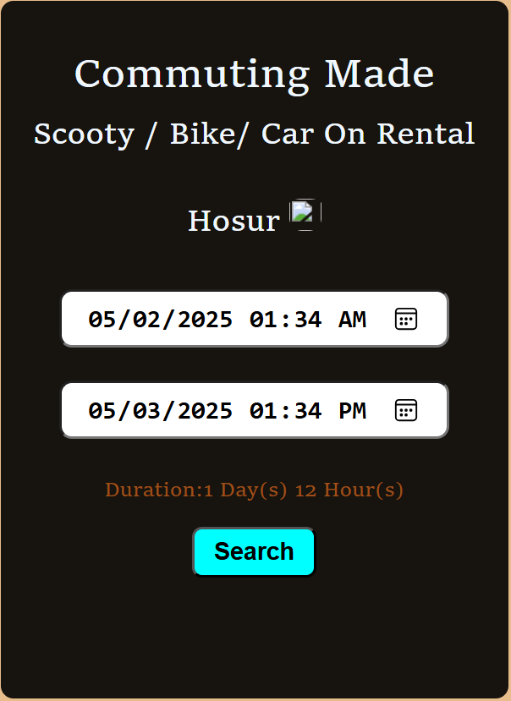

Vehicle Rental Duration Selection

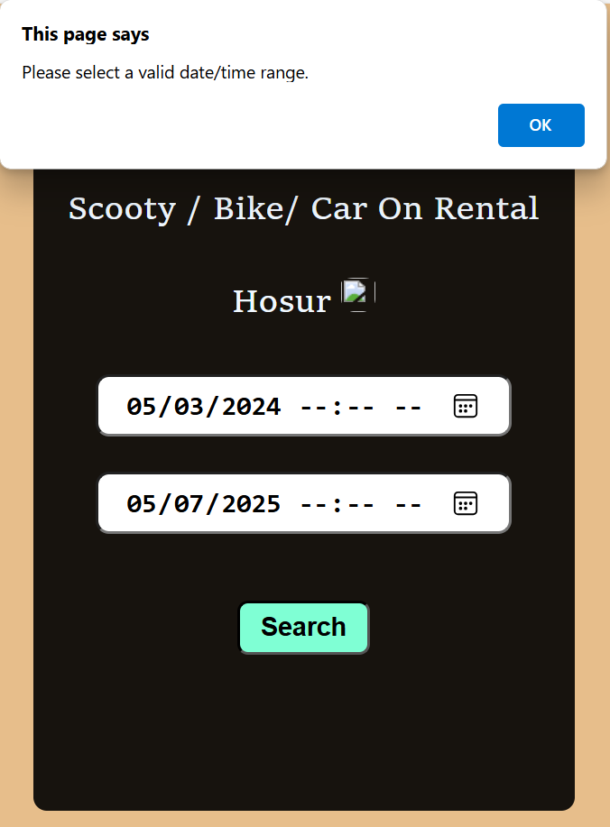

Vehicle Rental Duration Selection Error Pop-Up

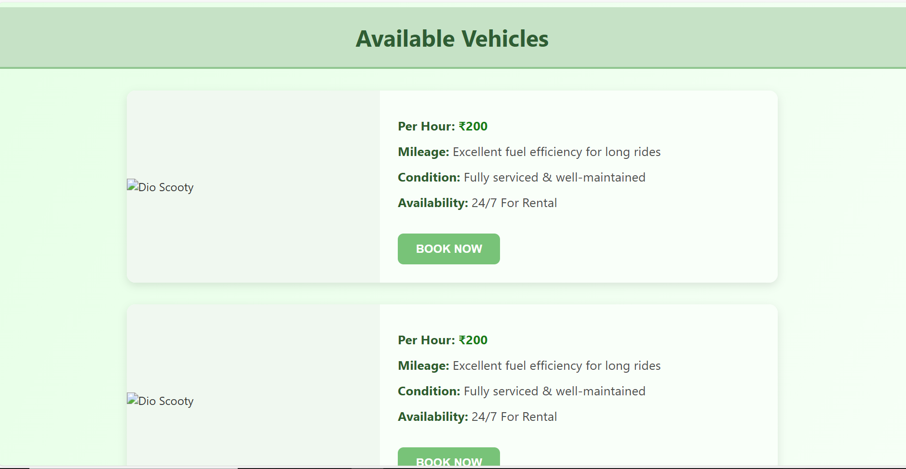

Available Vehicles for Rental

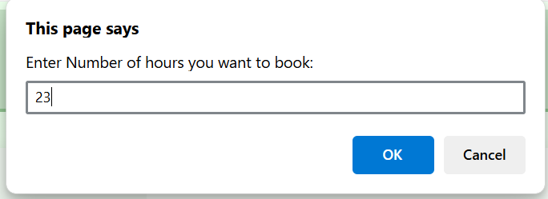

Booking Duration Input

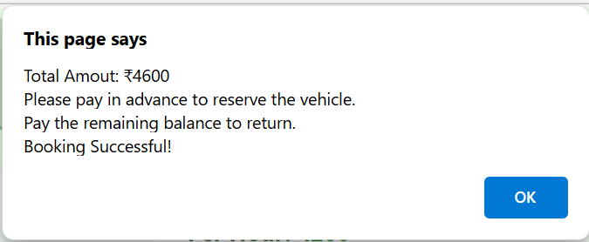

Booking Confirmation: Rental Amount and Instructions

## 5. CONCLUSION

The **Online Vehicle Management System** is an advanced solution that redefines the way vehicles are rented and managed. By shifting from traditional, paper-based systems to a fully digital platform, the system offers numerous benefits to both customers and administrators. Customers enjoy a seamless experience with the ability to search for available vehicles, submit bookings, and make payments—all in a few simple steps. The intuitive user interface, combined with real-time updates, enhances customer satisfaction by providing instant access to information on vehicle availability and booking statuses.

For administrators, the system simplifies vehicle management by automating key processes such as booking approvals, rental tracking, and vehicle maintenance. The centralized dashboard provides a comprehensive view of all transactions, helping administrators monitor operations efficiently and reduce manual efforts. Furthermore, the system’s scalability allows for future enhancements, including mobile app integration, GPS-based vehicle tracking, and more advanced payment options, ensuring the system remains adaptable to future needs.

In essence, the Online Vehicle Management System streamlines the vehicle rental process, improving both the efficiency of operations and the quality of customer service. By leveraging modern web technologies, the system delivers a robust, responsive, and secure platform that meets the demands of the modern-day vehicle rental industry. As the system continues to evolve, it is expected to play a significant role in enhancing the overall customer experience and operational efficiency in vehicle rental businesses.

## 6. BIBLIOGRAPHY

1. OpenAI: "GPT-3: Language Models for Text Generation." https://[www.openai.com](http://www.openai.com/)
2. GeeksforGeeks: "Computer Science Portal." [https://www.geeksforgeeks.org](https://www.geeksforgeeks.org/)
3. YouTube: “Various Tutorials and Educational Content." https://[www.youtube.com](http://www.youtube.com/)